Aim
To compute the string similarity for a given string s, defined as the sum of the lengths of the longest common prefixes between s and each of its suffixes (including itself).

Algorithm
The solution uses the Z-algorithm, which efficiently computes how much of the string matches with its prefix starting from each position
- Input: A string s of length n.
- Initialize:
  - Create an array Z of size n.
  - Z[i] will store the length of the longest substring starting at i that matches the prefix of s.
  - Maintain a window [left, right] representing the current matching segment.
- Build Z-Array:
For each index i from 1 to n-1:
  - If i is inside the current window (i ≤ right):
    - Copy previously computed values:
    - Z[i] = min(right − i + 1, Z[i − left])
  - Extend the match manually:
    - Compare characters from the prefix with characters starting at i.
    - Increase Z[i] while characters match.
  - If the new match goes beyond right:
    - Update left = i
    - Update right = i + Z[i] − 1
- Compute Similarity Sum:
  - The full string matches itself → contributes n
  - Add all values in the Z-array
- Return the total sum

Program:
import java.util.*;
import java.util.stream.*;

class Result {

/*
* Complete the 'stringSimilarity' function below.
*
* The function is expected to return a LONG.
* The function accepts STRING s as parameter.
*/

public static long stringSimilarity(String s) {

int n = s.length();
int[] Z = new int[n];
int left = 0, right = 0;

// Build Z-array
for (int i = 1; i < n; i++) {

if (i <= right) {
Z[i] = Math.min(right - i + 1, Z[i - left]);
}

while (i + Z[i] < n && s.charAt(Z[i]) == s.charAt(i + Z[i])) {
Z[i]++;
}

if (i + Z[i] - 1 > right) {
left = i;
right = i + Z[i] - 1;
}
}

long sum = n; // include similarity with itself
for (int val : Z) {
sum += val;
}

return sum;
}
}

public class Solution {
public static void main(String[] args) throws IOException {

BufferedReader bufferedReader = new BufferedReader(new InputStreamReader(System.in));
BufferedWriter bufferedWriter;

String outputPath = System.getenv("OUTPUT_PATH");
if (outputPath != null) {
bufferedWriter = new BufferedWriter(new FileWriter(outputPath));
} else {
bufferedWriter = new BufferedWriter(new OutputStreamWriter(System.out));
}

int t = Integer.parseInt(bufferedReader.readLine().trim());

IntStream.range(0, t).forEach(tItr -> {
try {
String s = bufferedReader.readLine();

long result = Result.stringSimilarity(s);

bufferedWriter.write(String.valueOf(result));
bufferedWriter.newLine();

} catch (IOException ex) {
throw new RuntimeException(ex);
}
});

bufferedReader.close();
bufferedWriter.close();
}
}
Output:
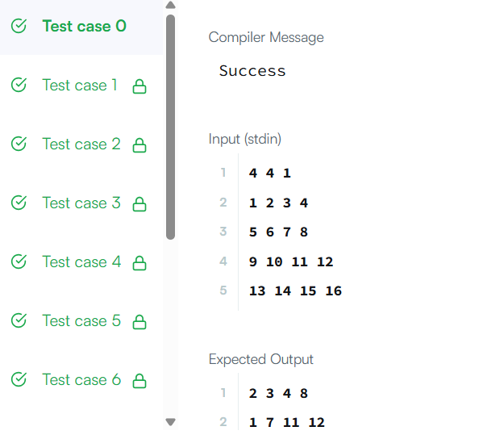

Result: The function returns a long value representing the total similarity score.

Aim
To find all strings in the array that are substrings of another string in the same array.

Algorithm
Given an array words, identify every word that appears inside any other word.

Steps:
- Let n be the number of words.
- Create an empty list ans to store results.
- For each word words[i]:
  - Compare it with every other word words[j] where i ≠ j.
  - Check if words[j] contains words[i] using .contains().
- If yes:
  - Add words[i] to the result list.
  - Stop checking further for that word (avoid duplicates).
- Return the list ans.

Program:

import java.util.*;

class Solution {

public List<String> stringMatching(String[] words) {

int n = words.length;

List<String> ans = new ArrayList<>();

for (int i = 0; i < n; ++i) {

for (int j = 0; j < n; ++j) {

if (i != j && words[j].contains(words[i])) {

ans.add(words[i]);

break;

}

}

}

return ans;

}

Output:

}: 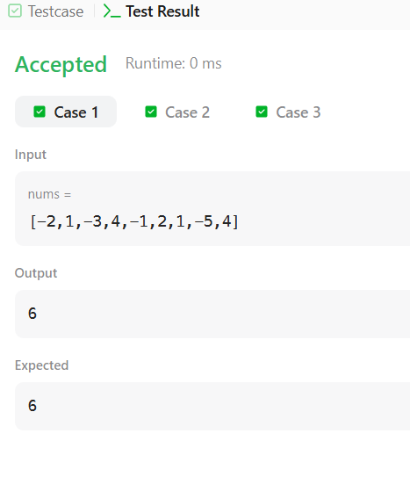

Result
The function returns a list of strings that are substrings of another word in the array.

Aim
To determine whether two strings share at least one common character (i.e., whether they have a non-empty common substring of length 1).

Algorithm
The solution uses a HashSet to efficiently check character overlap.

Steps:
- Input: Two strings s1 and s2.
- Store characters of first string
  - Create a HashSet<Character>.
  - Add every character from s1 into the set.
- Check characters of second string
  - For each character in s2:
    - If it exists in the set → common character found.
- Return result
  - If any common character exists → return "YES"
  - Otherwise → return "NO"
Program:
import java.io.*;
import java.util.*;
import java.util.stream.*;
class Result {

/*
* Complete the 'twoStrings' function below.
*
* The function is expected to return a STRING.
* The function accepts following parameters:
* 1. STRING s1
* 2. STRING s2
*/

public static String twoStrings(String s1, String s2) {

HashSet<Character> set = new HashSet<>();

// Add all characters from s1
for (char c : s1.toCharArray()) {
set.add(c);
}

// Check if any character of s2 is in s1
for (char c : s2.toCharArray()) {
if (set.contains(c)) {
return "YES";
}
}

return "NO";
}
}

public class Solution {
public static void main(String[] args) throws IOException {

BufferedReader bufferedReader = new BufferedReader(new InputStreamReader(System.in));
BufferedWriter bufferedWriter;

String outputPath = System.getenv("OUTPUT_PATH");
if (outputPath != null) {
bufferedWriter = new BufferedWriter(new FileWriter(outputPath));
} else {
bufferedWriter = new BufferedWriter(new OutputStreamWriter(System.out));
}

int q = Integer.parseInt(bufferedReader.readLine().trim());

IntStream.range(0, q).forEach(qItr -> {
try {
String s1 = bufferedReader.readLine();
String s2 = bufferedReader.readLine();

String result = Result.twoStrings(s1, s2);

bufferedWriter.write(result);
bufferedWriter.newLine();

} catch (IOException ex) {
throw new RuntimeException(ex);
}
});

bufferedReader.close();
bufferedWriter.close();
}
}

Output:
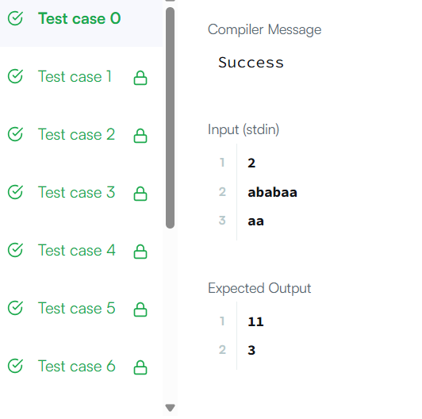

Result
The function returns:
- "YES" → if the two strings share at least one character
- "NO" → if they share none

Aim
To check whether one string (goal) can be obtained by rotating another string (s).

Algorithm
This solution uses a clever string property of rotations.

Steps:
- Check lengths
  - If s and goal have different lengths → rotation is impossible → return false.
- Concatenate the string
  - Create a new string: s + s
  - This contains all possible rotations of s.
- Check substring
  - If goal appears inside s + s, then goal is a rotation of s.
- Return result
  - If found → true
  - Otherwise → false

Program:
class Solution {
public boolean rotateString(String s, String goal) {
if (s.length() != goal.length()) {
return false;
}
return (s + s).contains(goal);
}
}

Output:
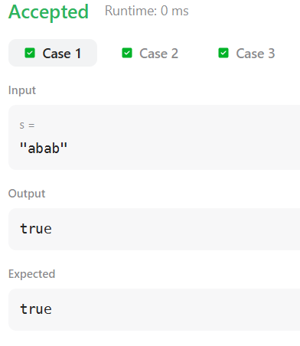

Result
Thus,The function returns and true → if goal is a rotation of and false → otherwise verified

Aim
To count how many characters were altered in a received message that should consist of repeated "SOS" signals.

Algorithm
- The original message is a repetition of "SOS" (e.g., SOS, SOSSOS, SOSSOSSOS…).
- Traverse the string character by character.
- For each index i:
  - If i % 3 == 0 → expected 'S'
  - If i % 3 == 1 → expected 'O'
  - If i % 3 == 2 → expected 'S'
- Compare the actual character with the expected one.
- If different → increment the error counter.
- Return the total count of altered characters.

Program:
import java.io.*;
import java.util.*;

class Result {

/*
* Complete the 'marsExploration' function below.
*
* The function is expected to return an INTEGER.
* The function accepts STRING s as parameter.
*/

public static int marsExploration(String s) {

int count = 0;

for (int i = 0; i < s.length(); i++) {

if (i % 3 == 0) { // Expected 'S'
if (s.charAt(i) != 'S') count++;
}
else if (i % 3 == 1) { // Expected 'O'
if (s.charAt(i) != 'O') count++;
}
else { // Expected 'S'
if (s.charAt(i) != 'S') count++;
}
}

return count;
}
}

public class Solution {
public static void main(String[] args) throws IOException {

BufferedReader bufferedReader = new BufferedReader(new InputStreamReader(System.in));
BufferedWriter bufferedWriter;

String outputPath = System.getenv("OUTPUT_PATH");
if (outputPath != null) {
bufferedWriter = new BufferedWriter(new FileWriter(outputPath));
} else {
bufferedWriter = new BufferedWriter(new OutputStreamWriter(System.out));
}

String s = bufferedReader.readLine();

int result = Result.marsExploration(s);

bufferedWriter.write(String.valueOf(result));
bufferedWriter.newLine();

bufferedReader.close();
bufferedWriter.close();
}
}

Output:

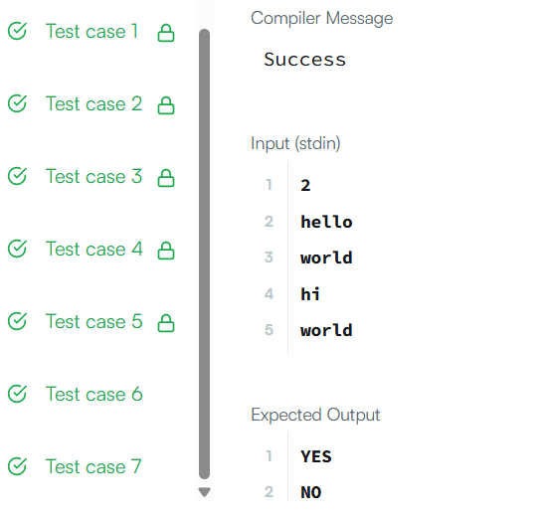

Result
Returns an integer representing the number of changed characters.

Aim
To find all starting indices in string s where an anagram of string p occurs.

Algorithm
- Create two frequency arrays:
  - pFreq → frequency of characters in p
  - sFreq → frequency of current window in s
- Fill pFreq using characters of p.
- Use a sliding window on s:
  - Expand window by moving right
  - Update sFreq for the new character
- Maintain window size equal to p.length():
  - If window becomes larger → remove left character and move left
- Compare sFreq and pFreq:
  - If equal → current window is an anagram → add left index to result
- Continue until end of string

Program:
class Solution {
public List<Integer> findAnagrams(String s, String p) {

List<Integer> ans = new ArrayList<>();

int[] pFreq = new int[256];
int[] sFreq = new int[256];

int left = 0, len;
for (int i = 0; i < p.length(); i++) {
pFreq[p.charAt(i) - 'a']++;
}
for (int right = 0; right < s.length(); right++) {
sFreq[s.charAt(right) - 'a']++;

len = right - left + 1;
while (len > p.length()) {
sFreq[s.charAt(left) - 'a']--;
left++;
len = right - left + 1;
}

if (isAnagrams(sFreq, pFreq)) {
ans.add(left);
}
}

return ans;
}

private boolean isAnagrams(int[] sFreq, int[] pFreq) {
for (int i = 0; i < 256; i++) {
if (sFreq[i] != pFreq[i]) return false;
}
return true;
}
}
Output:
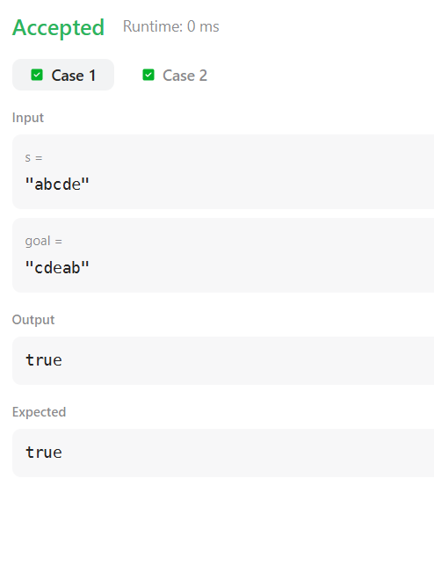
Result:
Thus, To find all starting indices in string s where an anagram of string p occurs.

Aim
To find the index of a character which, when removed, makes the string a palindrome.
If the string is already a palindrome or cannot be made one by removing a single character, return -1.

Algorithm
- Use two pointers:
  - left at start
  - right at end
- Move inward while characters match.
- On first mismatch:
  - Check if removing the left character makes the remaining substring a palindrome
→ If yes, return left
  - Otherwise check removing the right character
→ If yes, return right
- If neither works → return -1
- If loop finishes without mismatch → string already palindrome → return -1
Program:
import java.io.*;
import java.util.*;
import java.util.stream.*;
class Result {

/*
* Complete the 'palindromeIndex' function below.
*
* The function is expected to return an INTEGER.
* The function accepts STRING s as parameter.
*/

public static int palindromeIndex(String s) {

int left = 0;
int right = s.length() - 1;

while (left < right) {

if (s.charAt(left) == s.charAt(right)) {
left++;
right--;
} else {

// Remove left character
if (isPalindrome(s, left + 1, right)) {
return left;
}

// Remove right character
if (isPalindrome(s, left, right - 1)) {
return right;
}

return -1;
}
}

return -1; // Already palindrome
}

private static boolean isPalindrome(String s, int l, int r) {
while (l < r) {
if (s.charAt(l) != s.charAt(r)) return false;
l++;
r--;
}
return true;
}
}

public class Solution {
public static void main(String[] args) throws IOException {

BufferedReader bufferedReader = new BufferedReader(new InputStreamReader(System.in));
BufferedWriter bufferedWriter;

String outputPath = System.getenv("OUTPUT_PATH");
if (outputPath != null) {
bufferedWriter = new BufferedWriter(new FileWriter(outputPath));
} else {
bufferedWriter = new BufferedWriter(new OutputStreamWriter(System.out));
}

int q = Integer.parseInt(bufferedReader.readLine().trim());

IntStream.range(0, q).forEach(qItr -> {
try {
String s = bufferedReader.readLine();

int result = Result.palindromeIndex(s);

bufferedWriter.write(String.valueOf(result));
bufferedWriter.newLine();

} catch (IOException ex) {
throw new RuntimeException(ex);
}
});

bufferedReader.close();
bufferedWriter.close();
}
}

Output:
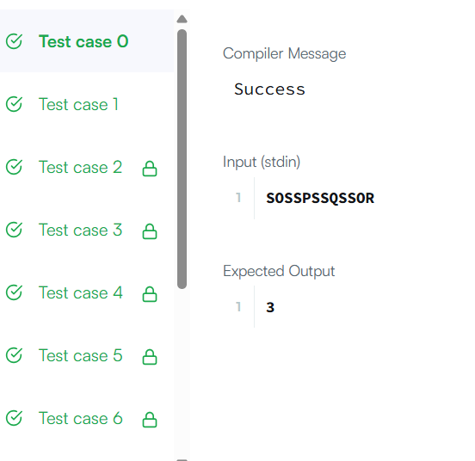

Result:
This program finds an index whose removal makes the string a palindrome, otherwise returns minus one.

Aim
To find the first index where string needle appears in haystack.

Algorithm
- Slide a window of size needle.length() over haystack.
- For each position, extract the substring.
- Compare it with needle.
- If equal → return the starting index.
- If no match found → return -1.

Program:
class Solution {
public int strStr(String haystack, String needle) {
for(int i = 0, j = needle.length(); j<=haystack.length(); i++,j++){
if(haystack.substring(i,j).equals(needle)){
return i;
}
}
return -1;
}
}
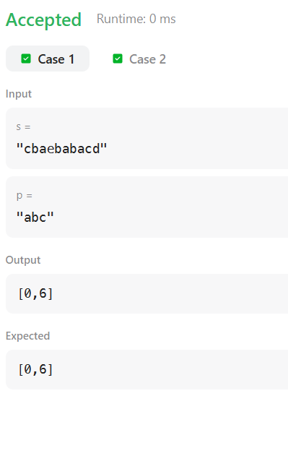 import java.io.*;
import java.util.*
import java.util.stream.*;
while (l >= L && r <= R && t.charAt(l) == t.charAt(r))
buffere

bResult :
Thus, find the first index where string needle appears in haystack.

Aim
To compute the length of the longest palindromic substring for each rotation of a given string s.
- A rotation moves the first character to the end.
- Output a list of integers representing the maximum palindrome length for each rotation.

Algorithm
- Input: string s of length n.
- Create a doubled string: t = s + s. This allows easy generation of all rotations via substrings of length n.
- For each rotation starting at index i = 0 to n-1:
  - Consider substring rotation = t[i : i + n].
  - Find the longest palindromic substring within this substring:
    - Use center expansion: for each character, expand around it for odd and even length palindromes.
    - Keep track of maximum palindrome length.
  - Add maximum length to the result list.
- Return the list of lengths for all rotations.
Optimization notes:
- Using the doubled string avoids repeated substring allocations.
- Expanding from the center for palindromes is O(n²) per rotation.
- Full Manacher’s algorithm can reduce per-rotation computation to O(n) in advanced solutions
Program:
import java.io.*;
import java.util.*;
import java.util.stream.*;
import static java.util.stream.Collectors.joining;

class Result {

public static List<Integer> circularPalindromes(String s) {

int n = s.length();
String t = s + s;
List<Integer> res = new ArrayList<>(n);

for (int start = 0; start < n; start++) {

int max = 1;
int L = start;
int R = start + n - 1;

for (int center = L; center <= R; center++) {

// Odd length
int l = center, r = center;
while (l >= L && r <= R && t.charAt(l) == t.charAt(r)) {
max = Math.max(max, r - l + 1);
l--;
r++;
}

// Even length
l = center;
r = center + 1;
while (l >= L && r <= R && t.charAt(l) == t.charAt(r)) {
max = Math.max(max, r - l + 1);
l--;
r++;
}
}

res.add(max);
}

return res;
}
}

public class Solution {
public static void main(String[] args) throws IOException {

BufferedReader bufferedReader = new BufferedReader(new InputStreamReader(System.in));
BufferedWriter bufferedWriter = new BufferedWriter(
new FileWriter(System.getenv("OUTPUT_PATH")));

int n = Integer.parseInt(bufferedReader.readLine().trim());
String s = bufferedReader.readLine();

List<Integer> result = Result.circularPalindromes(s);

bufferedWriter.write(
result.stream()
.map(Object::toString)
.collect(joining("\n")) + "\n"
);

bufferedReader.close();
bufferedWriter.close();
}
}

Output:

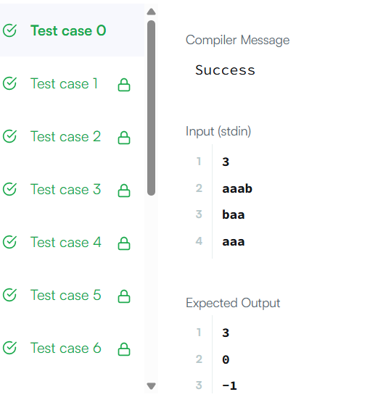

Result: For each rotation of the string, return the length of its longest palindromic substring

